

**AWT PRACTICAL**

**Student Details :-**

* Name :- Ankit Senjaliya
* Enrollment No. :- 19BT04046
* Branch :- Computer Science And Engineering
* Semester :- 5

**Faculty Mentor Details :-**

* Ms. Pooja Shah

1. Write a program to check student grade based on marks

Description:

Write a program to check student grade based on the marks using if-else statement.

Conditions:

•If marks are 60% or more, grade will be First Division.

•If marks between 45% to 59%, grade will be Second Division.

•If marks between 33% to 44%, grade will be Third Division.

•If marks are less than 33%, student will be Fail.

<?php

echo "Name :- Ankit Senjaliya";

echo "<br>Enrollment No. :- 19BT04046";

$marks = 55;

if ($marks >= 60) {

$grade = "First Division";

} else if ($marks >= 45 && $marks <= 59) {

$grade = "Second Division";

} else if ($marks >= 33 && $marks <= 44) {

$grade = "Third Division";

} else {

$grade = "Fail";

}

echo "<p>Student Grade = $grade";

?>

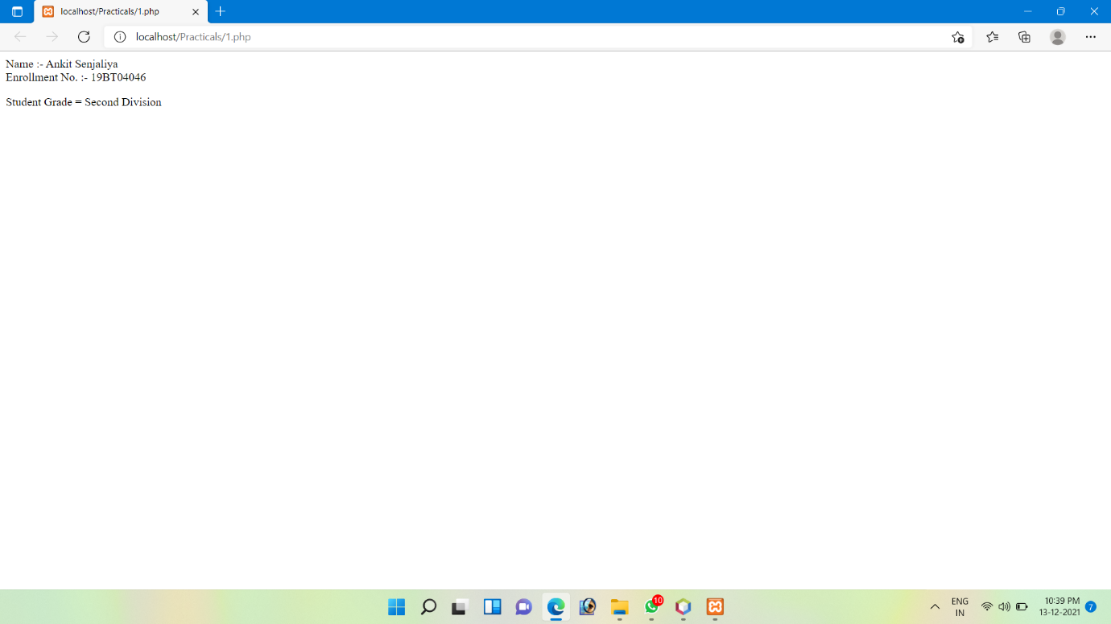

2. Write a program to show day of the week using switch

Description:

Write a program to show day of the week (for example: Monday) based on numbers using

switch/case statements.

Conditions:

•You can pass 1 to 7 number in switch

•Day 1 will be considered as Monday

•If number is not between 1 to 7, show invalid number in default

<?php

echo "Name :- Ankit Senjaliya";

echo "<br>Enrollment No. :- 19BT04046";

$day = "9";

switch($day){

case "1":

echo "<p>Monday";

break;

case "2":

echo "<p>Tuesday";

break;

case "3";

echo "<p>Wednesday";

break;

case "4";

echo "<p>Thursday";

break;

case "5";

echo "<p>Friday";

break;

case "6";

echo "<p>Saturday";

break;

case "7";

echo "<p>Sunday";

break;

default:

echo "<p>Invaild Day";

}

?>

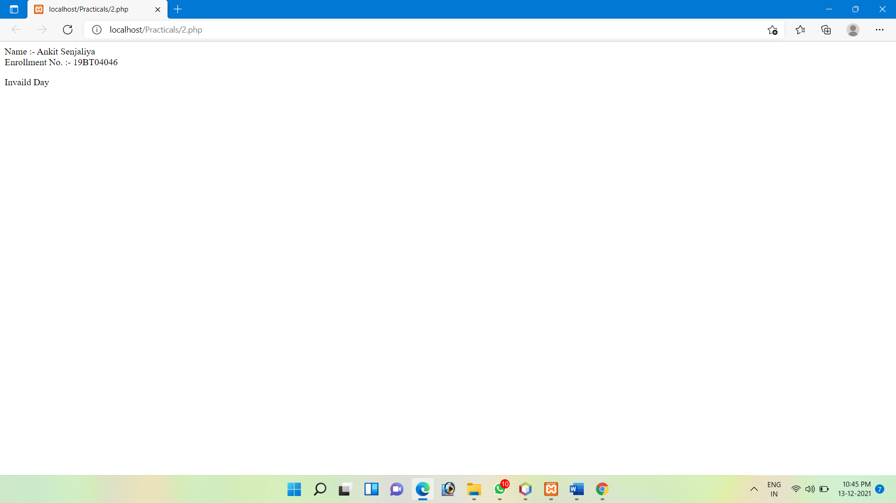

3. Write a factorial program using for loop in php

Description:

Write a program to calculate factorial of a number using for loop in php.

<?php

echo "Name :- Ankit Senjaliya";

echo "<br>Enrollment No. :- 19BT04046";

$no = 5;

$fac = 1;

for($y=$no; $y>=1; $y--){

$fac = $fac * $y;

}

echo "<p>The factorial of $no is $fac";

?>

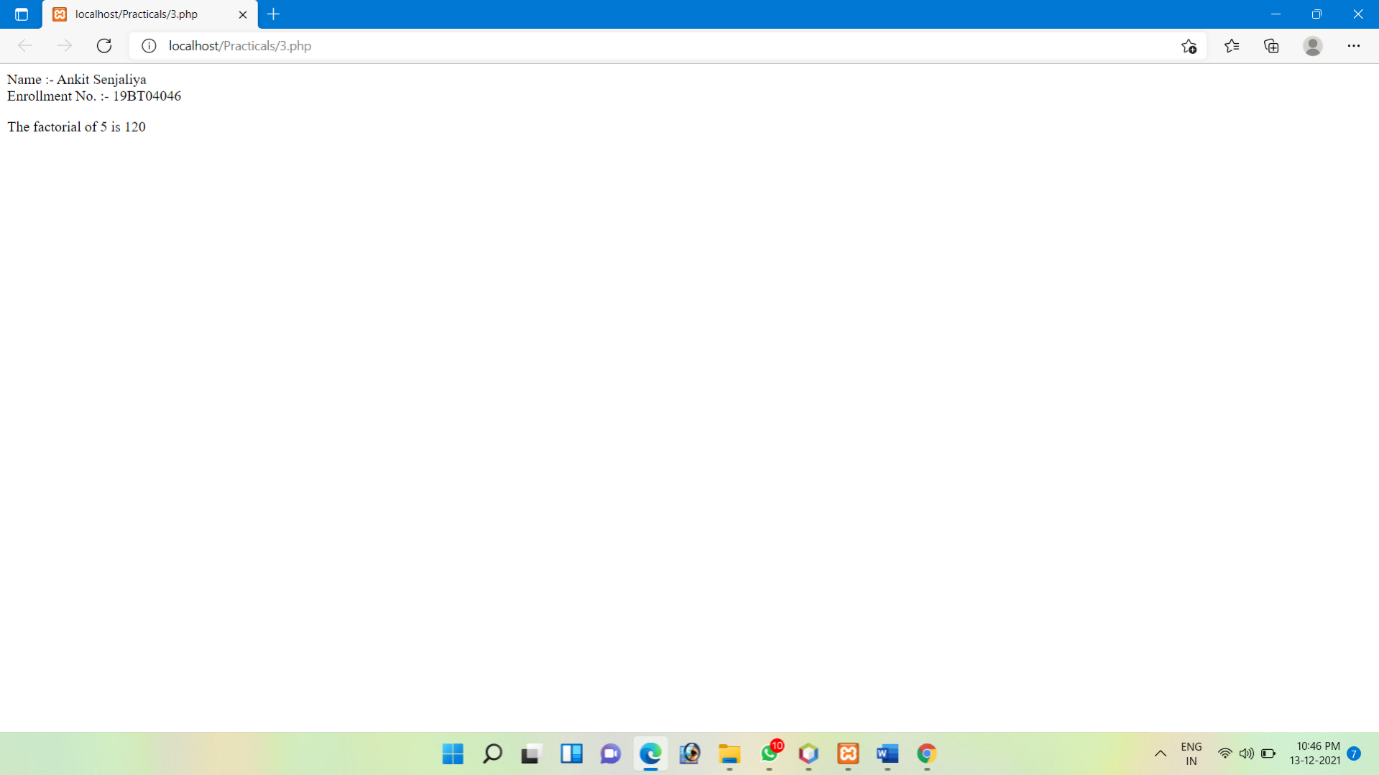

4. Factorial program in PHP using recursive function

Exercise Description:

Write a PHP program to find factorial of a number using recursive function.

What is Recursive Function?

•A recursive function is a function that calls itself.

<?php

echo "Name :- Ankit Senjaliya";

echo "<br>Enrollment No. :- 19BT04046";

function fac($no){

if($no < 2){

return 1;

}else{

return ($no * fac($no - 1));

}

}

echo "<p>";

echo fac(8);

?>

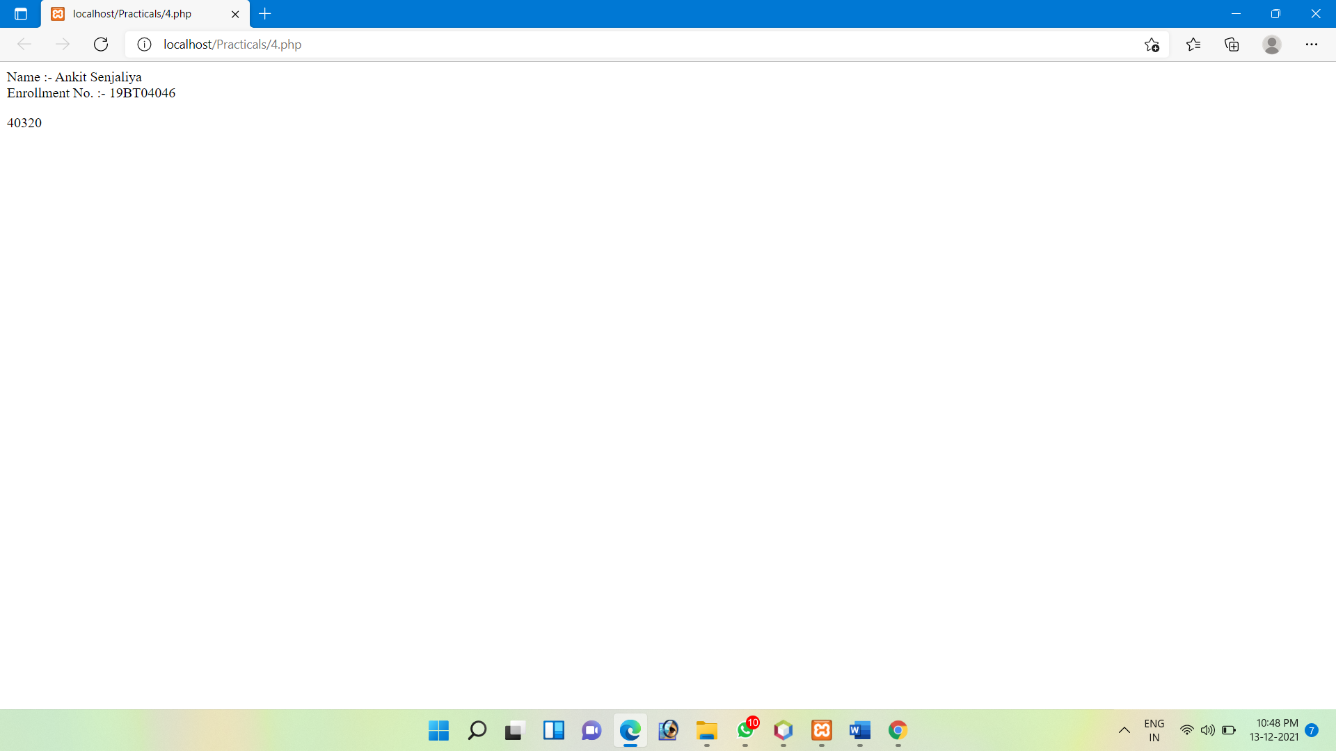

5. Write a program to create Chess board in PHP using for loop

Description:

Write a PHP program using nested for loop that creates a chess board.

Conditions:

•You can use html table having width=”400px” and take “30px” as cell height and width for

check boxes.

<table width = "400px"

cellspacing = "0px"

cellpadding = "0px"

border = "1px">

<?php

echo "Name :- Ankit Senjaliya";

echo "<br>Enrollment No. :- 19BT04046";

for($row=1; $row<=8; $row++){

echo "<p>";

echo "<tr>";

for($column=1; $column<=8; $column++){

$total = $row + $column;

if($total%2 == 0){

echo "<td height = 40px width = 40px bgcolor=#FFFFFF></td>";

}else {

echo "<td height = 40px width = 40px bgcolor=#OOOOOO></td>";

}

}

echo "<tr>";

}

?>

</table>

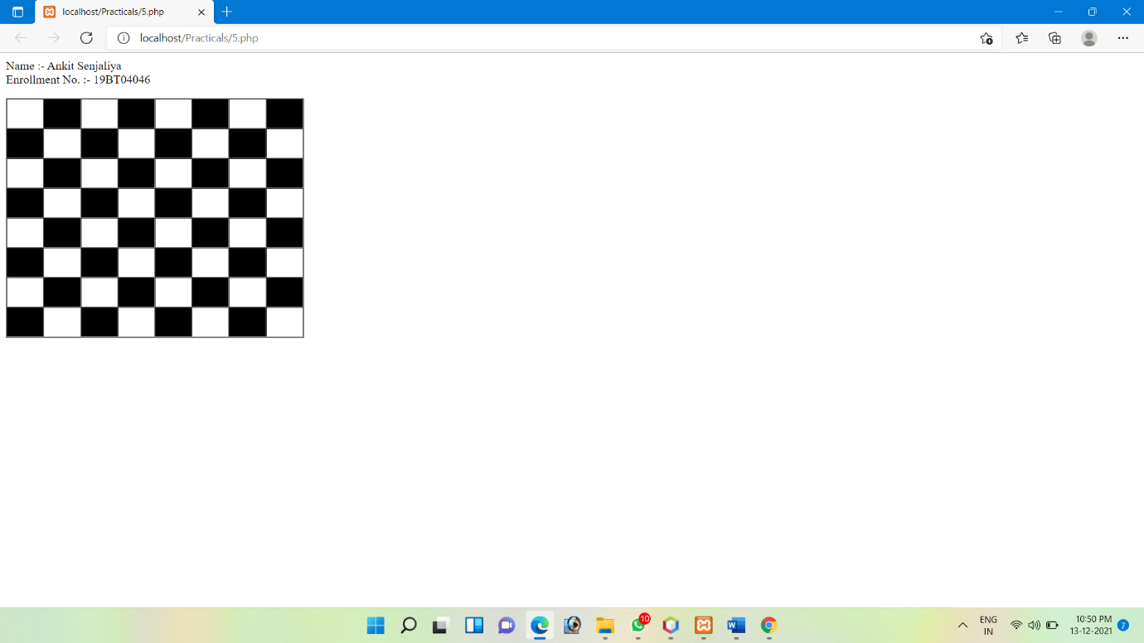

7. Write a PHP program to check if a person is eligible to vote

Description:

Write a PHP program to check if a person is eligible to vote or not.

Condition

•Minimum age required for vote is 18.

•You can use PHP Functions.

•You can use Decision Making Statements.

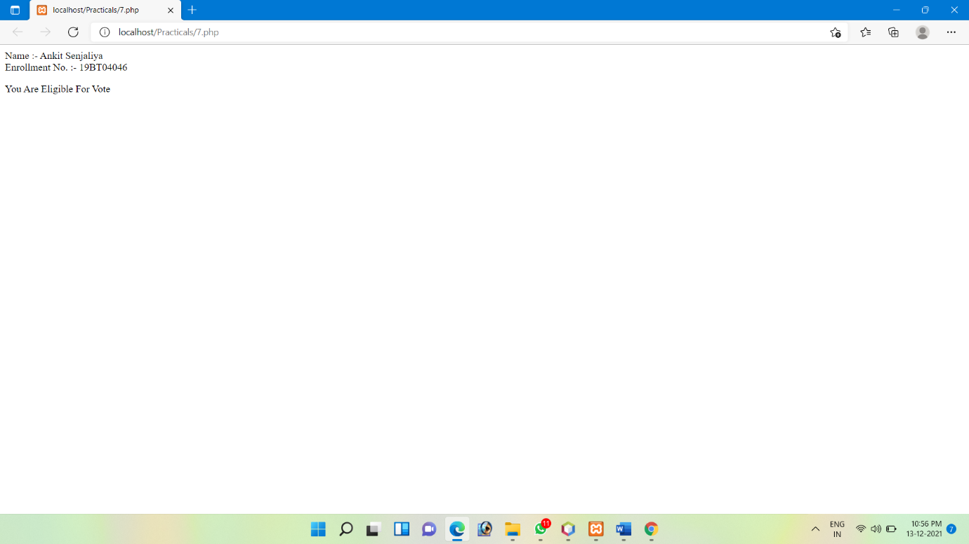

8. Write a PHP program to calculate area of rectangle

Description:

Write a PHP program to calculate area of rectangle by using PHP Function.

Condition

•You must use a PHP Function.

•There should be two arguments i.e., length & width.

<?php

echo "Name :- Ankit Senjaliya";

echo "<br>Enrollment No. :- 19BT04046";

function rectangle_area(){

$length = 60;

$width = 40;

{

$area = $length * $width;

echo "<p>Ractangle Area = $area";

}

}

rectangle_area();

?>

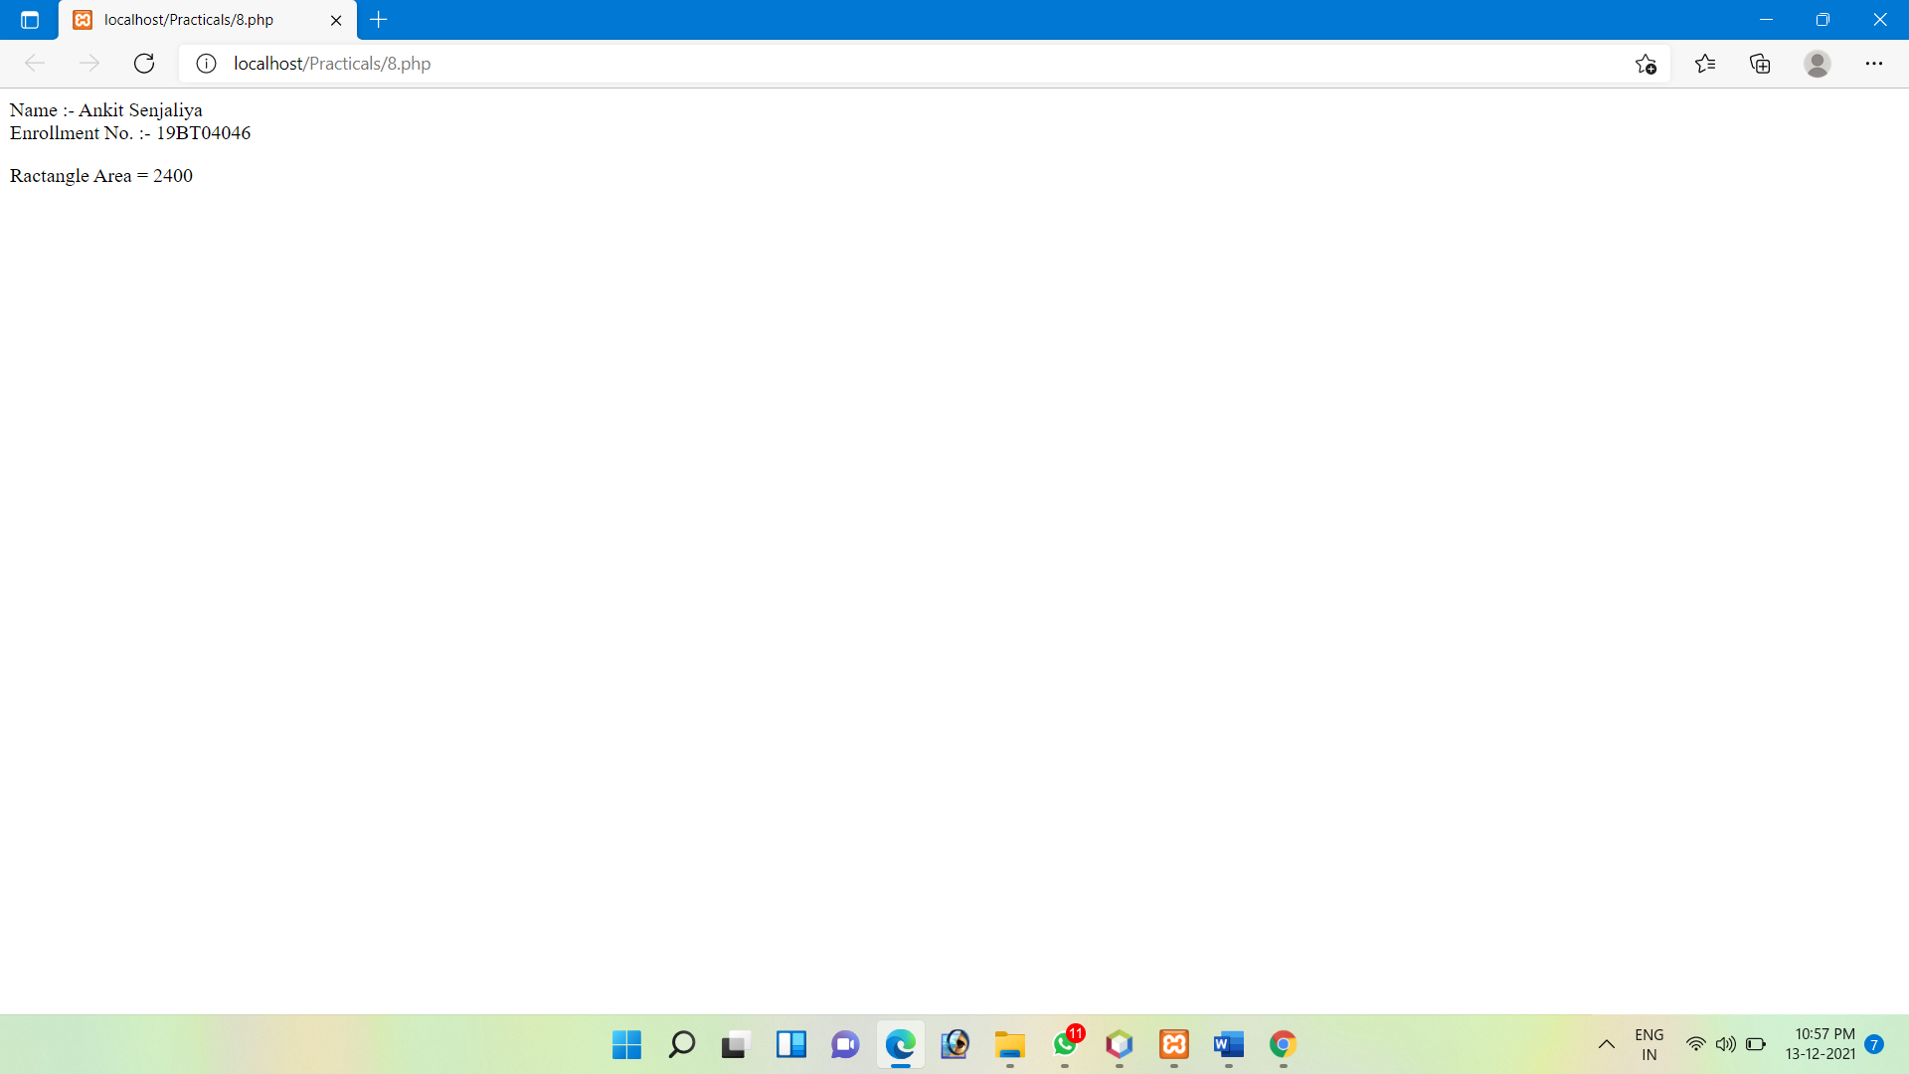

9. Palindrome Number

A palindrome number is a number which remains same when its digits are reversed.

For example, number 24142 is a palindrome number. On reversing it we’ll get the same number.

Logic:

•Take a number.

•Reverse the input number.

•Compare the two numbers.

•If equal, it means number is palindrome

<?php

echo "Name :- Ankit Senjaliya";

echo "<br>Enrollment No. :- 19BT04046";

echo "<p>";

?>

<form method="post">

Enter a Number: <input type="text" name="num"/><br>

<button type="submit">Check</button>

</form>

<?php

if($_POST)

{

$num = $_POST['num'];

$reverse = strrev($num);

if($num == $reverse){

echo "The number $num is Palindrome";

}else{

echo "The number $num is not a Palindrome";

}

}

?>

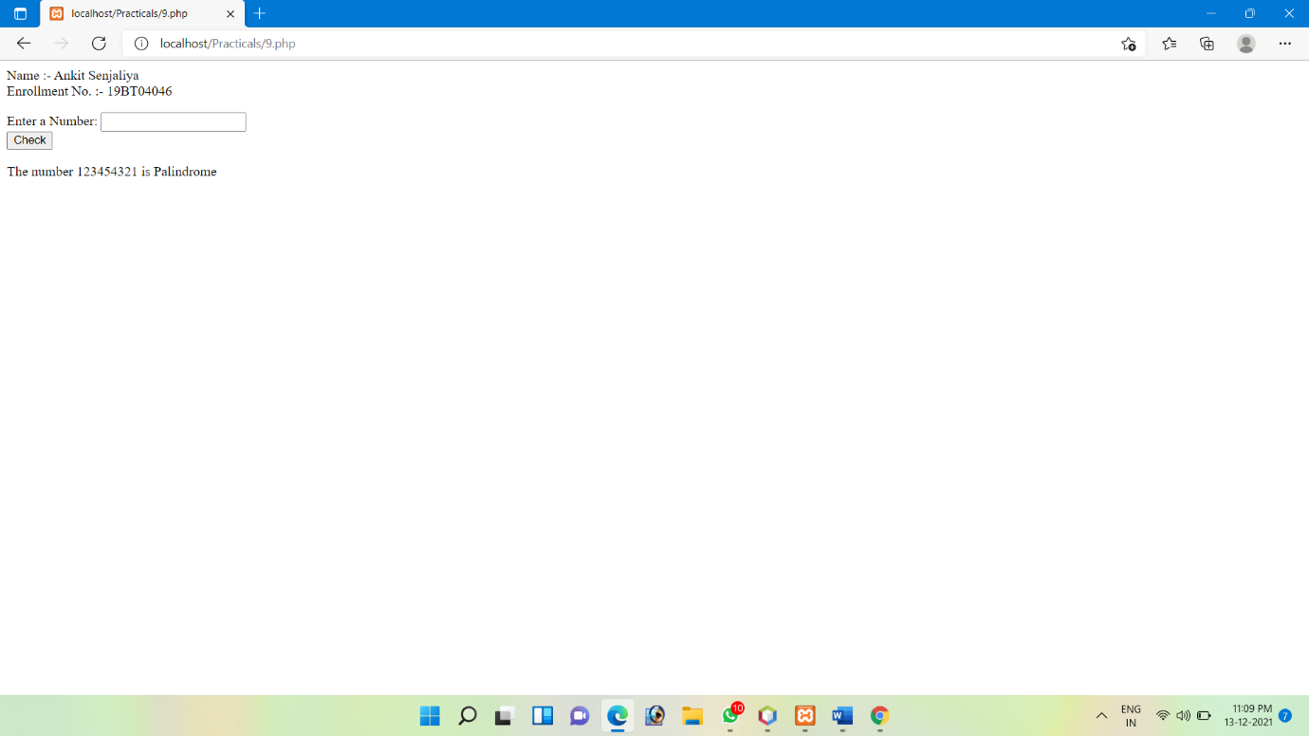

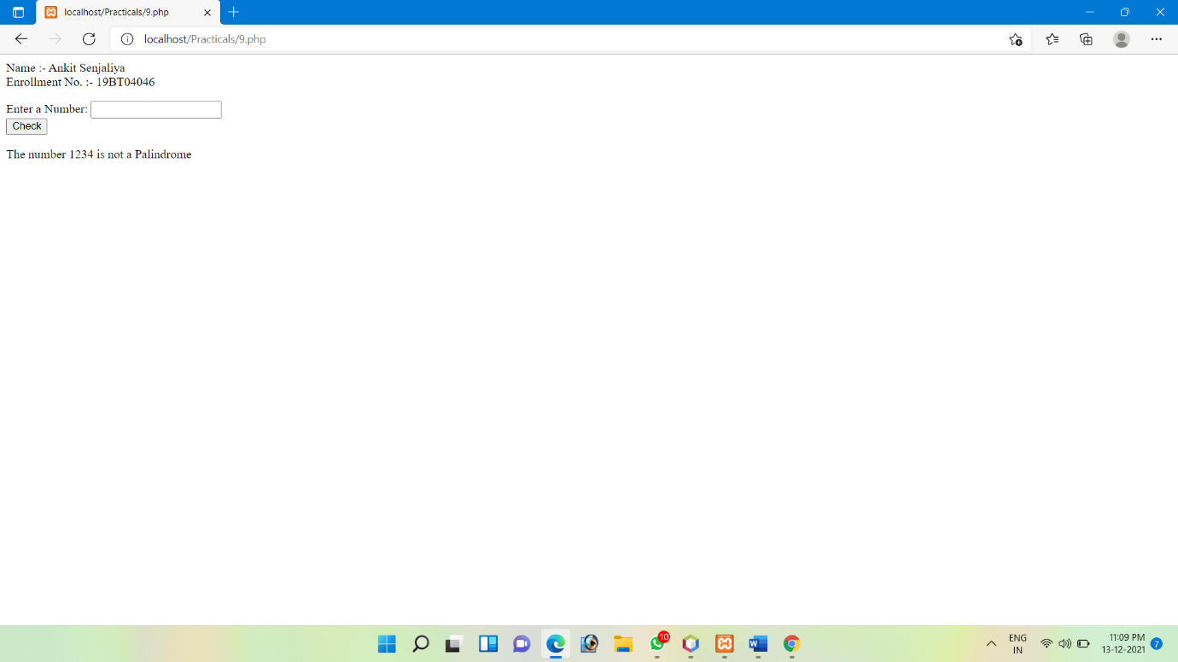

10. Sum of Digits

To find sum of digits of a number just add all the digits.

Logic:

•Take the number.

•Divide the number by 10.

•Add the remainder to a variable.

•Repeat the process until remainder is 0.

<?php

echo "Name :- Ankit Senjaliya";

echo "<br>Enrollment No. :- 19BT04046";

$num = 3241;

$sum = 0;

$rem = 0;

echo "Number = $num <br><br>";

for($i = 0; $i<=strlen($num); $i++){

$rem = $num % 10;

$sum = $sum + $rem;

$num = $num / 10;

}

echo "Sum Of Digit Is = $sum";

?>

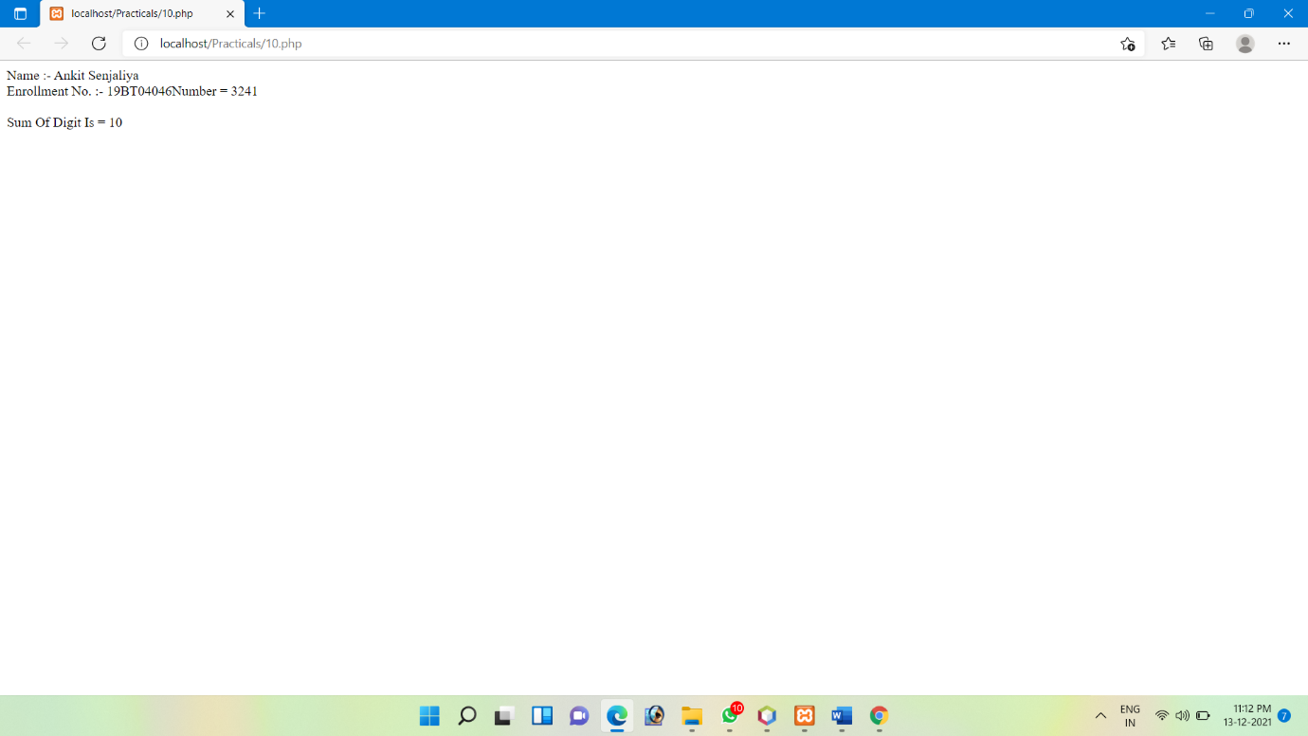

11. Swapping two numbers

Two numbers can be swapped or interchanged. It means first number will become second and

second number will become first.

There are two methods for swapping:

•By using third variable.

•Without using third variable.

<?php

echo "Name :- Ankit Senjaliya";

echo "<br>Enrollment No. :- 19BT04046";

echo "<p>";

$a = 10;

$b = 20;

echo "Before Swapping <br> a = $a <br> b = $b <br> <br>";

$c = $a;

$a = $b;

$b = $c;

echo "After Swapping <br> a = $a <br> b = $b <br><br>";

$d = 30;

$e = 40;

echo "Before Swapping <br> d = $d <br> e = $e <br> <br>";

$d = $d + $e;

$e = $d - $e;

$d = $d - $e;

echo "After Swapping <br> d = $d <br> e = $e <br>";

?>

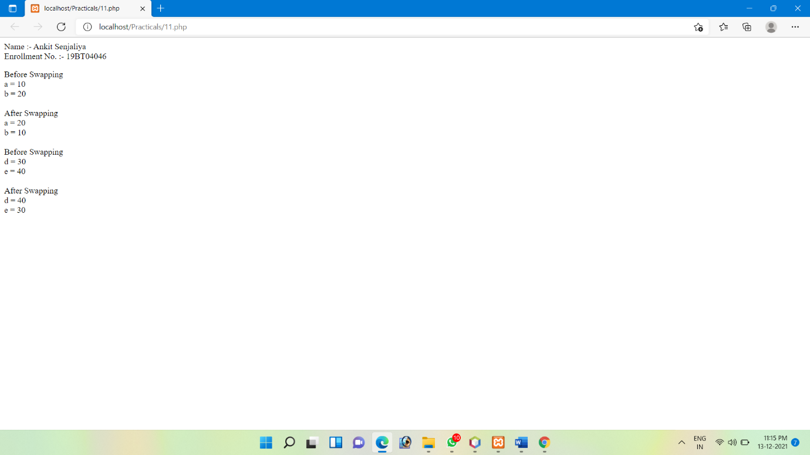

12. Date format

Print below on screen:

Today is 19-08-2021

Today is 19/08/2021

Today is 19.08.2021

Today is 2021/08/19

Today is 2021-08-19

Today is 2021.08.19

Today is Thursday

print default timezone

Set timezone to Europe/Berlin

and then show the current date and time for that

Show current time

Create date 15 Aug 2021 3 pm and display in day/month/year hour.min.sec format

Display this string “25 April 2016 5:30pm “ to month/day/year hour.min,sec format

Display tomorrow’s date

Display next Sunday date

Display after 6 months date

<?php

echo "Name :- Ankit Senjaliya";

echo "<br>Enrollment No. :- 19BT04046";

echo "<p>";

echo " Today Is " .date("D-M-Y"). "<br><br>";

echo " Today Is " .date("d-m-Y"). "<br><br>";

echo " Today Is " .date("d/m/Y"). "<br><br>";

echo " Today Is " .date("d.m.Y"). "<br><br>";

echo " Today Is " .date("Y/m/d"). "<br><br>";

echo " Today is " .date("Y-m-d"). "<br><br>";

echo " Today is " .date("Y.m.d"). "<br><br>";

echo " Today Is " .date("l"). "<br><br>";

date_default_timezone_set("Europe/Berlin");

echo date_default_timezone_get();

echo "<br><br>";

echo " Today Date In Europe Is " .date("d-m-Y"). "<br>";

echo " The Time Is " .date("h:i:sa");

echo "<br><br>";

date_default_timezone_set("Asia/Kolkata");

echo "Current Time Is " .date("h:i:sa");

echo "<br><br>";

$d = mktime(15, 0, 0, 10, 15, 2021);

echo " <br> Created Date Is " .date("d/M/Y h:i:sa" , $d);

echo "<br><br>";

echo "String to date Conversation :- ";

echo date("d-m-Y h:i:sa", strtotime("25 April 2016 5:30pm")). "\n";

echo "<br><br>";

echo "Tomorrow`s Date Is :- ";

echo date("d-m-Y h:i:sa", strtotime("Tomorrow")). "\n";

echo "<br><br>";

echo "Next Sunday :- ";

echo date("d-m-Y h:i:sa", strtotime("next Sunday")). "\n";

echo "<br><br>";

echo "After 6 Month :- ";

echo date("d-m-Y h:i:sa", strtotime("+6 month")). "\n";

echo "<br><br>";

?>

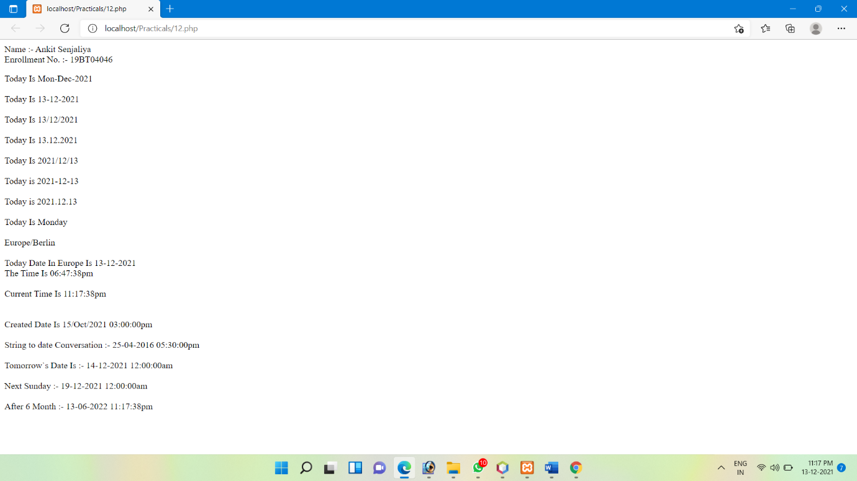

13. Create header file and include in it a php page

Header.php

<?php

echo "<h1> This Is a Header File </h1>";

?>

Include in php

<?php

echo "Name :- Ankit Senjaliya";

echo "<br>Enrollment No. :- 19BT04046";

include 'header.php';

?>

<h3> Include The Header File In PHP </h3>

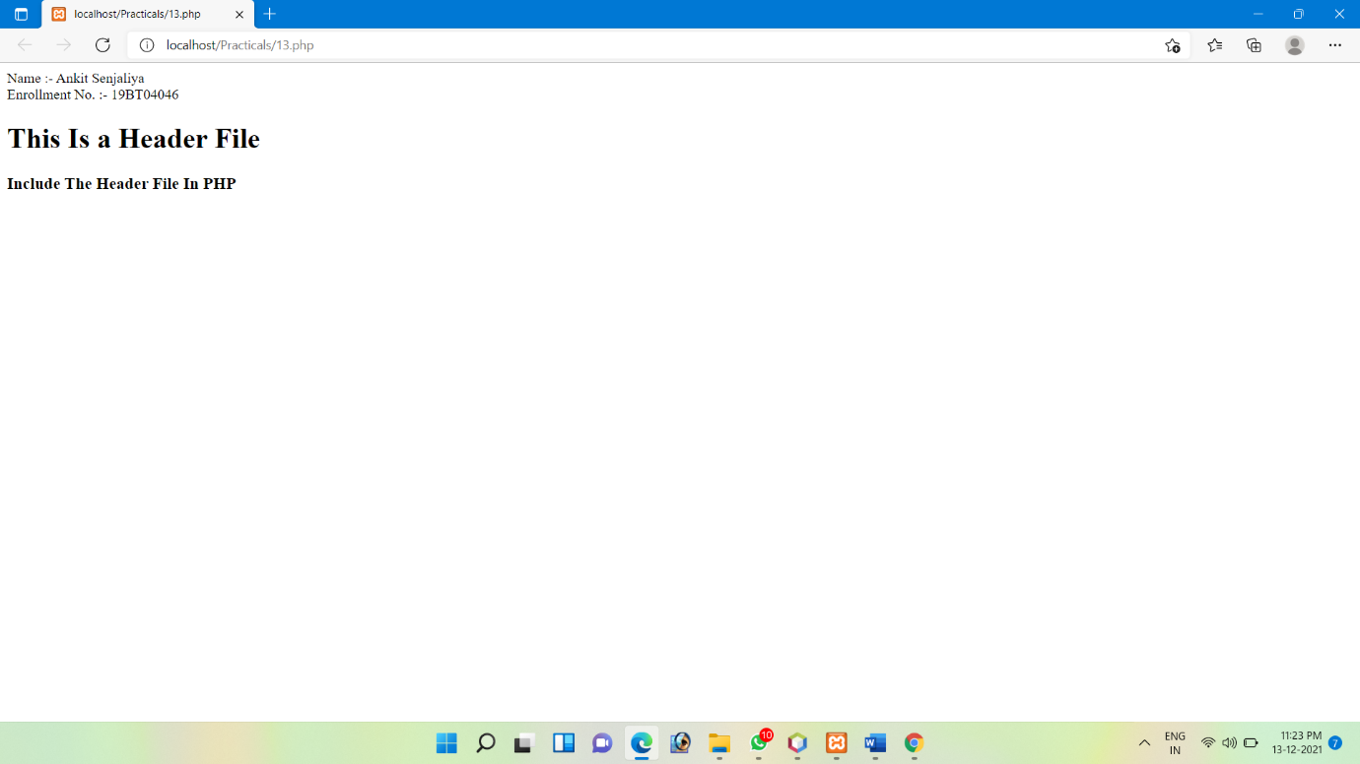

14. Create footer file and include it in php page

Footer.php

<?php

echo "<h1> This Is a Footer File </h1>" .date('d-m-Y');

?>

<a href="Footer.php"></a>

Include in php

<?php

echo "Name :- Ankit Senjaliya";

echo "<br>Enrollment No. :- 19BT04046";

include 'Footer.php';

?>

<h3> Include Footer File In php </h3>

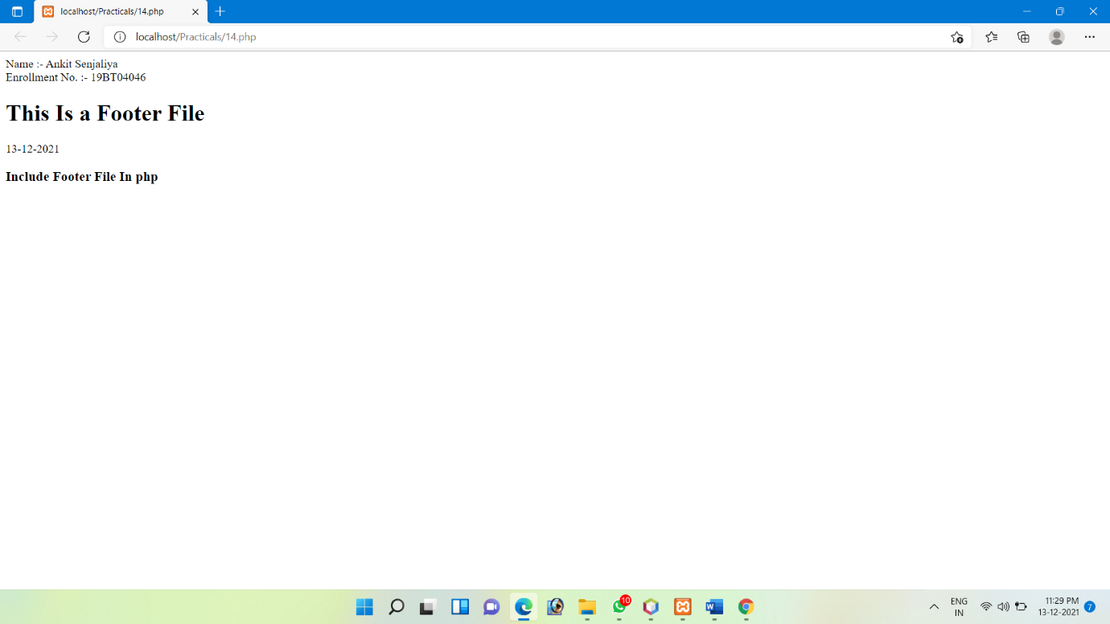

15. Open or create file and write in a file. Read that file.

For Create and write in the file

<?php

$myfile = fopen("newfile.txt", "w") or die("unable to open file!");

$txt = "Hello GSFCU <br><br>";

fwrite($myfile,$txt);

$txt = "It Is a Practical Program Using PHP <br><br>";

fwrite($myfile,$txt);

fclose($myfile);

?>

For Read That File

<?php

echo "Name :- Ankit Senjaliya";

echo "<br>Enrollment No. :- 19BT04046";

echo "<p>";

$myfile = fopen("newfile.txt", "r") or die("Unable to open file!");

echo fread($myfile,filesize("newfile.txt"));

fclose($myfile);

?>

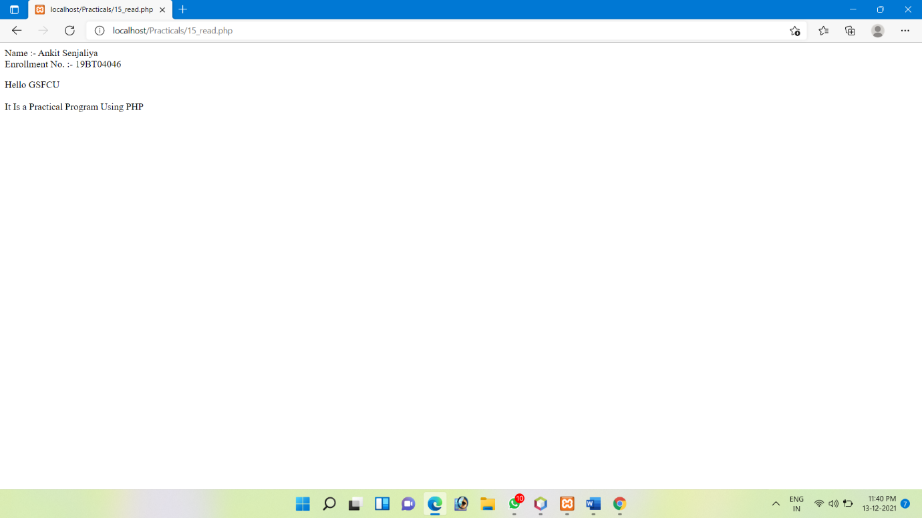

16. Open a file (created already) and append data in a file. Read that file.

For Append Data in the file

<?php

$fp = fopen('newfile.txt','a');

fwrite($fp, 'Append Date in php File');

fclose($fp);

?>

For Read that file.

<?php

echo "Name :- Ankit Senjaliya";

echo "<br>Enrollment No. :- 19BT04046";

$fp = fopen("newfile.txt", "r") or die("Unable to open file!");

echo fread($fp,filesize("newfile.txt"));

fclose($fp);

?>

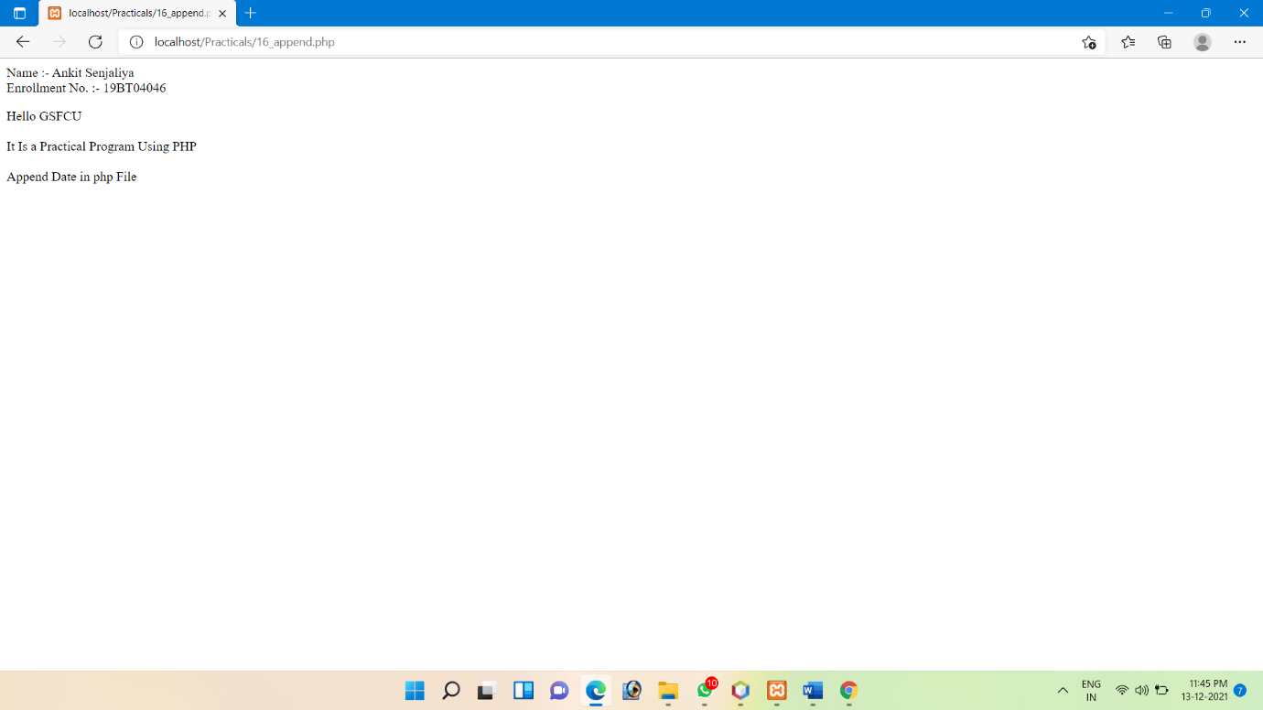

17. Read sample.txt file line by line.

Sample.txt

My Name is Raj.

I am studying PHP.

I am studying PHP in GSFC University.

I like to do programming.

I make sample programs in PHP.

I learned many concepts in PHP.

Read File Line by Line

<?php

echo "Name :- Ankit Senjaliya";

echo "<br>Enrollment No. :- 19BT04046";

echo "<p>";

$file = fopen("Sample.txt","r");

while(! feof($file))

{

echo fgets($file). "<br />";

}

fclose($file);

?>

